Lost in Time

By Lazaros Kalonis

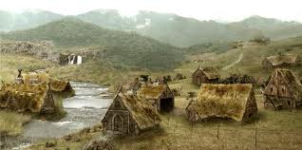

It all happened when I found a strange box under my bed. It had only two buttons, one red and one green. I pressed the red one and I was immediately transferred to a place with lots of snow. And then, I realized…. The box was a time machine!

It was snowing heavily and I was surrounded by trees that seemed to be ancient. I started walking around so I could get warmer, since I only had my pyjamas on and I was freezing. After hours of walking, I finally spotted a tiny village far away. As soon as I noticed there was civilization, I started running towards it, and in less than ten minutes I was there! The women in the village told me I was in Scandinavia and that they were Vikings! I was terrified! I had heard that the Vikings were cruel pirates that killed without mercy, like primitives.

Despite all my concerns the villagers treated me like one of their own. The woman that took care of me, named Emma, was very sweet. She explained to me every single detail about their civilization, informing me that only males killed, only when they had to, especially when they were defending their kingdom.
After lunch,-which was mouth-watering by the way-, she showed me her house. It was made of wood and the roof was covered with straw. It was quite plain indeed, but there were some decorations, such as a bull’s head, something very common in that area!

After I had learnt all that, I realized that the rest of the world had a wrong image about this great civilization of the mighty Vikings, so I decided to stay there a bit longer and get to know them better.

